Requirements for Family Reunification
Norway

1. Background

Immigration to Norway

Immigration in Norway in Numbers (direct source SSB)

- Persons with an immigrant background
As of 1 January 2016, around 848 000 persons residing in Norway were either immigrants (699 000) or born in Norway to two immigrant parents (150 000). These groups combined make up 16 percent of the population of Norway.
- From many different countries
The population of Norway includes persons with backgrounds from 223 different countries and autonomous regions. The largest groups of immigrants are from Poland, Lithuania and Somalia.
- In all municipalities
There are immigrants in all Norwegian municipalities, most are in Oslo and Drammen, where immigrants and Norwegian-born to immigrant parents make up 32,5 and 28 percent of the population respectively in 2016.
- Many young immigrants
Immigrants and Norwegian-born to immigrant parents are, on average, much younger than the population in general. The immigrant group is made up of a large number of young adults. Half of all immigrants in Norway are aged between 20 and 40. Only 9 percent are over the age of 60. Children born to immigrants in Norway are even younger. Slightly more than half are below the age of 10, 80 per cent are under 20 and just 1,7 per cent are over 40 years of age.
- Period of residence
There are major disparities in how long immigrants have lived in Norway. Some groups, including those from Pakistan, Vietnam, Turkey and Morocco, have lived in Norway for a long time, while immigrants from the new EU countries – particularly Poland and Lithuania – have lived in Norway for a shorter period of time; mostly less than five years. Refugees from Somalia, Iraq and Afghanistan have also lived in Norway for a relatively short period of time.
- Various reasons for immigrating
Immigrants move to Norway due to work, family, as refugees or to study. Since 2007, work has been the most common reason for immigration, followed by family immigration.

Figure 1: Immigrants in numbers
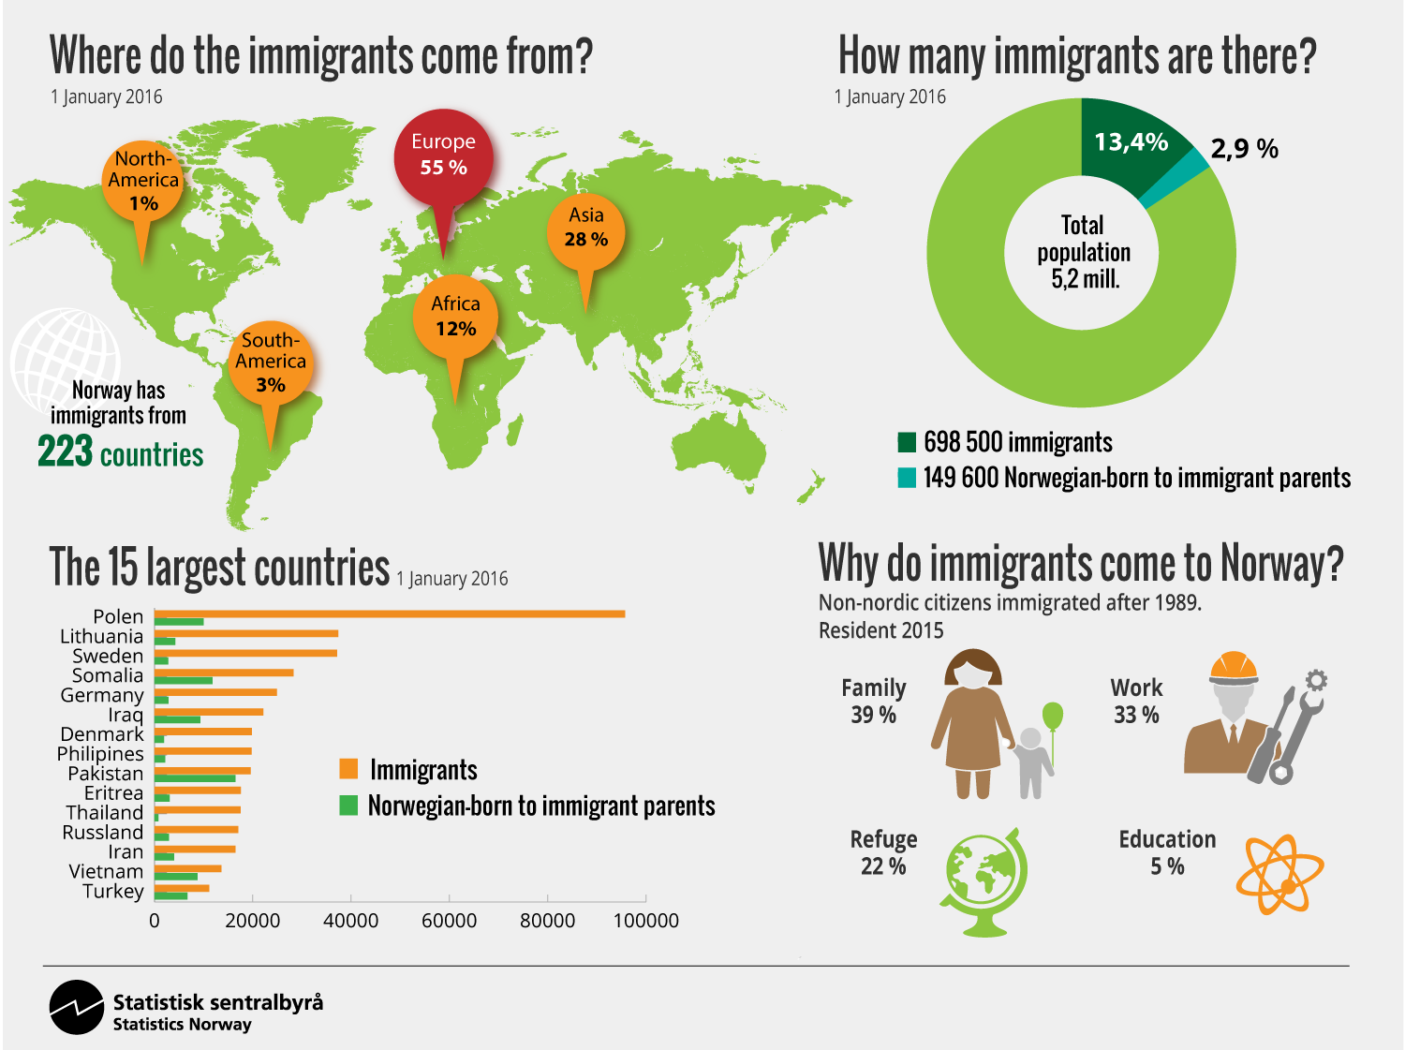
Kilde: SSB: https://www.ssb.no/_image/225144/label/

Figure 2: Immigrations and country of origin
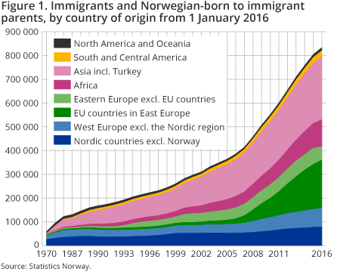
Kilde: SSB; https://www.ssb.no/en/innvandring-og-innvandrere/nokkeltall/immigration-and-immigrants

The main reason for non-Nordic citizens immigrating to Norway in the period 1990-2014 as a whole was immigration motivated by family connections. Following the south-eastward expansion of the EU, the amount of labour migration has exceeded the amount of family migration. However, the rise in EU labour migration has also meant a corresponding increase in the number of family immigrants, particularly in relation to family reunification.
In 2005 the number of labour immigrants exceeded the number of family immigrants. In a comparative perspective, the most interesting finding is the high number of work related immigration in the period 2006-2015.

Figure 3: Non-Nordic immigrants by reason for immigration
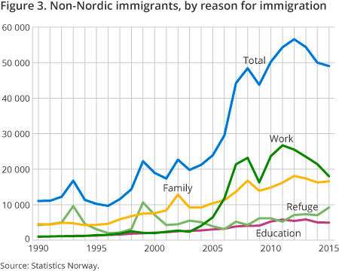
Kilde: SSB; https://www.ssb.no/en/innvandring-og-innvandrere/nokkeltall/immigration-and-immigrants

Refugees in Norway
At the start of 2015, 188 000 persons with a refugee background were living legally in Norway. A total of 138 000 have refugee status, 35 000 (25 percent of the total refugees) have come through family reunification with a refugee and 15 000 through the establishment of a family with a refugee. The 188 000 refugees come from a total of 169 different countries), mostly from Somalia, Iraq and Iran.

Figure 4: Persons with refugee background 2000-2016
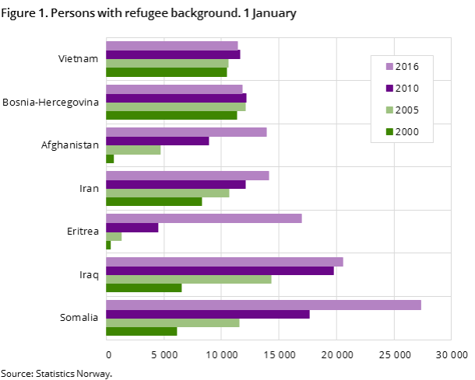
Kilde: SSB; https://www.ssb.no/en/befolkning/statistikker/innvgrunn/aar-flyktningbakgrunn

Family immigration to Norway
Growing number of family reunifications
Until 2002, the number of immigrants moving to Norway for the purpose of reunification and establishment was roughly the same. Since the turn of the millennium, there has been a significant increase in family reunifications. This is a result of a greater influx of migrant workers from countries such as Germany, and in particular the EU countries that joined the EU as part of the expansions in 2004, 2007 and 2013. In 2004, 4 400 immigrants came to Norway for purposes of reunification, and since 2007 the figure has remained at around 10 000 a year. In 2014, 12 300 immigrants were reunited with their families.
The number of immigrants who came to Norway for purposes of establishment increased from 1 600 in 1990 to 4 900 in 2015.
As shown in the figure below, most of the family immigrants in the 25-year period we are studying are from Poland, followed by Thailand, Somalia and Iraq. However, the type of family immigration varies from country to country, and the two largest groups clearly illustrate these disparities: while the majority of Poles have come here for family reunification in recent years, most Thais are here for family establishment.
Figure 5: Number of family immigrations by type of family immigration 1990-2014
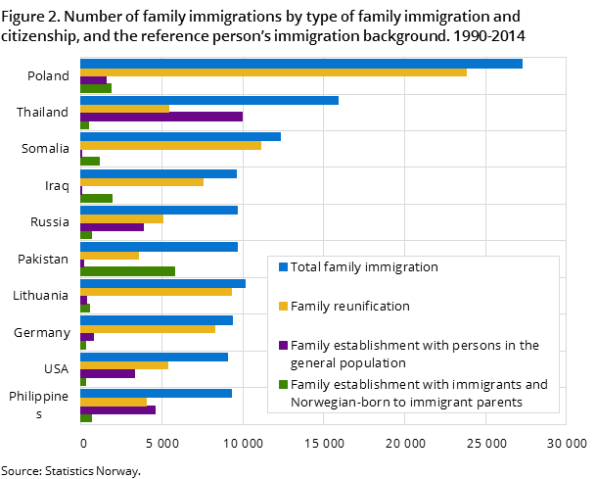
Kilde: SSB; https://www.ssb.no/en/innvandring-og-innvandrere/nokkeltall/immigration-and-immigrants

For the period 1990-2014 as a whole, most family establishment immigrants were from Pakistan. In 2014, the number of people who came here for purposes of family establishment and family reunification was roughly the same; 185 and 165 persons respectively. The virtual halt in labour immigration in 1975 and limits on the number of asylum seekers and refugees have also led to a drop in reunification immigrants from Pakistan.

Immigration policies and administration

The actors in the immigration administration are described in figure below.
Figure 6: Immigration adminisitration
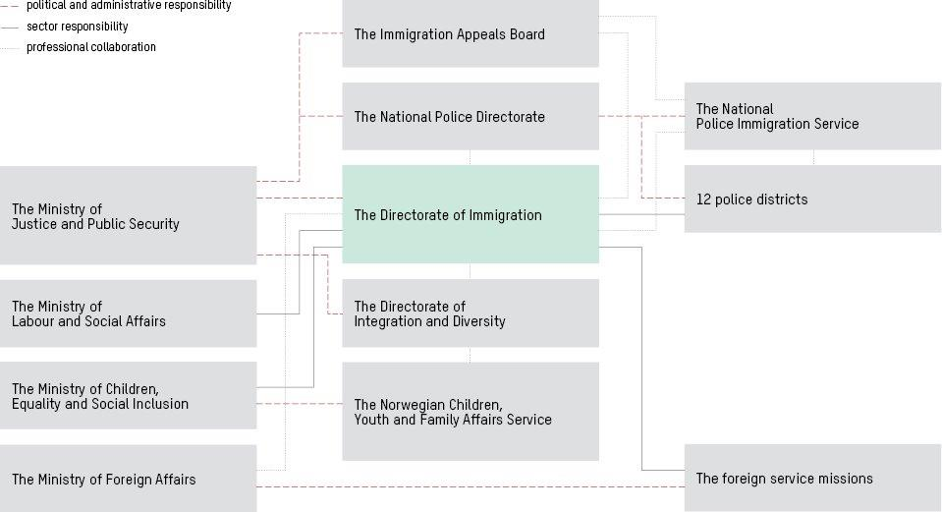
Kilde: Oxford Research AS

The UDI's task
The Directorate of Immigration (UDI) is the central agency in the Norwegian immigration administration. The UDI implements and helps to develop the government’s immigration and refugee policy.
The UDI is tasked with facilitating lawful and desirable immigration and ensuring that those who meet the requirements are given an opportunity to come to Norway. At the same time, however, they have a control function and are tasked with preventing abuses of the system.
UDI processes applications for protection (asylum), visitor's visas, family immigration, residence permits for work and study purposes, citizenship, permanent residence permits and travel documents. UDI also makes decisions on rejection and expulsion.

The Ministry of Justice and Public Security
The Ministry of Justice and Public Security is responsible for refugee, immigration and integration policy and governs the UDI and UNE through laws and regulations, budgets and allocation letters.
In the ministry, the Minister of Immigration and Integration is responsible for the Government's asylum, immigration and integration policy.

The Directorate of Integration and Diversity (IMDi)
The Directorate of Integration and Diversity (IMDi) implements the government's refugee settlement policy. IMDi’s function is based on the Introduction Act (the right and obligation to participate in tuition in the Norwegian language) and Report No. 49 to the Storting (2003–2004) “Diversity through inclusion and participation – Responsibility and freedom”.

The Immigration Appeals Board (UNE)
The Immigration Appeals Board (UNE) considers appeals against the UDI's decisions pursuant to the Immigration Act, the Immigration Regulations and the Nationality Act. UNE is superior to the UDI as a body for legal interpretation. This means that UNE's practice forms the basis for the UDI’s practice.

The National Police Immigration Service (PU)
The National Police Immigration Service (PU) registers asylum seekers, investigates asylum seekers' travel routes, ascertains their identities, and prepares and implements final rejections in asylum cases. PU coordinates and assures the quality of all deportations from Norway.

1.2 Changes in legislation (especially after 2010, but earlier as well if relevant)

Legal framework – family reunification

New law: Main regulation is Immigration act 2008, into force 1 January 2010
Here we will focus on changes in legislation when it comes to immigration act and requirements for family reunification. We will not describe all changes in integration related legislation.
The most important legal and regulatory framework relating to family reunification in Norway is the Immigration Act from 2008 and the Immigration Regulation. The Immigration Act and the corresponding Immigration Regulation came into force on 1.1.2010, replacing the older Immigration Act of 1988 and the Immigration Regulations of 1990. Further rules and regulations are given by the Ministry of Justice. Jurisprudence is also relevant when considering the law within the area. UDI also issues circulars regarding the applicable law and practice, which are applied by case workers on a case by case basis.
In June 2016 an agreement was reached about upcoming changes to immigration law. These changes are however not yet in force. We will describe the main rules from June 2016 below.
It is important to underline that the act and regulations that came into force in 2010, was a complete revision. It is not possible to describe all legal changes. The new immigration laws and regulations contained several important changes to the old immigration law from 1988. Here’s a list of the most important changes in family reunification legislation:

      - New in 2008/2010: “Stable and regular income” – Tightening the income requirement
The Immigration Act of 2010 introduced stricter requirements regarding income:
      - As a main rule, only the reference person can fulfil the income requirement
      - As a main rule, the income requirement has to be fulfilled also the year before application/permit: The reference person must provide documentation from the latest tax assessment showing that he or she satisfied the income requirement during the previous year
      - The reference person cannot have received financial support or qualification benefit from the social services during the last 12 months

- 2016: Increased subsistence in family immigration
In 2016, the Ministry of Justice decided to increase subsistence in family immigration cases to 305 200 NOK. The increase of subsistence is approximately 50 000 NOK, from the current subsistence claims 252 472 NOK (88 percent of the salary grade 19 in the state salary scale). The new requirement of 305 200 NOK corresponds to a salary grade 24 in the state salary scale. The initiative is a follow-up agreement between the government parties and Christian Democrats and Liberals. The changes take effect on 5.9.2016, and will apply to applications for family promoted (?) after this date. The old rule will apply to applications promoted (?) before 9.5.2016. (Correct term “promoted”? Can be)

- New in 2008/2010: “Staying requirement” - 4 years of work or studying in Norway – requirement to certain group of reference person (section 40a of the Immigration Act)
Section 40 A in the Immigration Act require a staying period for the reference person in certain situations. The requirement for staying period is that the reference person has worked or studied in Norway for four years.
The rule was introduced in the new Immigration Act of 2008. The intention with the rule was to reduce the number of asylum seekers who have no need for protection (immigration considerations). The intention was also to stimulate the group of references persons to integrate through work and studying (integration).

- New in 2008/2010: Concepts: Family reunification and family establishing.
The concepts family reunification and family establishment have legal consequences both regarding “staying requirement and income requirement.”

- New 2008/2010: A more detailed law – democracy and rule of law
The immigration laws of 2008 are more detailed than the immigration laws of 1988. The intention is that the Parliament should have more control over immigration and that the rules should be more accessible for the applicants and the citizens. Under the old law and legal framework, most of the changes were made by the ministry in regulations etc.

A short introduction to the Norwegian system – residence permits.
A residence permit based on family reunification is normally valid for one year, after which it must be renewed. Having held such a permit for three years, the foreigner may apply for a permanent residence permit. Until the permanent residence permit has been issued, it is required that the marriage with the reference person persists and that the parties live together. Once he/she has obtained a permanent residence permit, the foreigner is no longer required to uphold the requirements of family reunification in order to remain in Norway. If such a permit is granted, the foreigner will no longer be dependent on the relationship to the reference person.
With a permanent residence permit you can live and work in Norway indefinitely. You also have extra protection against expulsion. This used to be called a settlement permit. In order to apply for a permanent residence permit, you must have held a residence permit in Norway for at least three years and meet certain other requirements.
If you have a permanent residence permit, you will be issued a residence card that is valid for two years at a time. This is your proof that you have been granted a permanent residence permit. Previously, people with permanent residence permits had a sticker affixed to their passports.
According to the regulations and following an individual assessment, citizens of third countries may qualify for one of four main categories:
- Labour immigrants, i.e. persons who have received a concrete job offer
- Persons with close family ties to somebody residing in Norway
- Students, trainees, au pairs and participants in an exchange program
- Refugees and persons who qualify for a residence permit on humanitarian grounds

As a rule, students etc. are only granted a temporary residence permit, but students may work part time and change their status after receiving a job offer following the completion of their studies. Depending on the circumstances, persons in the other categories may be granted either a permanent or only a temporary residence permit.
In the following paragraphs we will concentrate on the most important rules regarding family immigration. We will also present the most important changes in legislation. The Immigration Act stipulates that close family members of Norwegian and Nordic nationals and of foreigners who have an unrestricted permit to reside in Norway, have the right to residence. The most important categories of close family members defined in the Immigration Regulations are:
- Spouse – both parties must be over 18, and they will have to live together
- Cohabitant – both parties must be over the age of 18, have lived together for at least two years and intend to continue their cohabitation. If the parties have joint children, the requirement of two years cohabitation does not apply
- Unmarried child under the age of 18
- Parents of an unmarried child below 18, if they satisfy certain conditions

1.3 Draft laws / bills

Draft laws
The most important draft bill is “Prop. 90 L (2015–2016) Endringer i utlendingsloven mv. (innstramninger II)”.
The most important changes when it comes to family reunification in this draft bill are:
- “To introduce stricter rules on family immigration, including a subsistence requirement for sponsors who are refugees or who have been granted subsidiary protection and a requirement that the sponsor has worked or studied for three years in Norway before family reunification can be granted. The three-year-requirement will apply to sponsors who are refugees or who have been granted subsidiary protection status, and also to sponsors who have been granted a residence permit on humanitarian grounds, and sponsors who have themselves come to Norway as family immigrants. The two requirements are necessary due to the unpredictable refugee situation in Europe, and are proposed as temporary measures which will last until 31 December 2019.
- To make it possible to refuse applications for family immigration with refugees and people who have been granted subsidiary protection in Norway, if the family in question would be able to live safely in a third country were the family’s over-all connection is stronger than its connection to Norway.
- To introduce integration criteria and requirements for a permanent residence permit, including a condition that the applicant has to support oneself in the twelve-month period prior to a permanent residence permit being granted. The applicant must also have a minimum level of spoken Norwegian and pass a test in social studies “.

Furthermore, on the basis of the asylum agreement between the Conservative Party, the Progress Party, the Christian Democratic Party and the Liberal Party, the Government proposes:
- To introduce a requirement were only those over the age of 24 are authorised to establish a family. The aim is to counter forced marriages
- To extend the required period of residence in Norway to be eligible for a permanent residence permit from three to five years.

New laws – but not yet in force
The draft bill has been debated in the Norwegian parliament. The Norwegian parliament (The Storting) has adopted a number of legislative amendments to ensure a more sustainable asylum policy and to strengthen border controls. These were approved by the King in Council on 22.06.2016. The Ministry is now considering the need for transitional rules and regulations for the period until the amendments come into force. When we describe the rules in chapter 2 and 3, we describe the rule.
In the following we describe the most important new rules regarding family reunification:
- “A new provision will make it possible to refuse certain applications for family reunification in cases where the sponsor has been granted subsidiary protection in Norway. Residence for family members may be refused if the family in question would be able to live safely in a third country with which the family’s overall connection is stronger than its connection with Norway. This provision does not apply if the sponsor has been granted permanent residence in Norway.
- A requirement that both parties must be at least 24 years old is being introduced in family establishment cases. The purpose of this requirement is to combat forced marriage. Exemptions may be made from this requirement if it is clear that the marriage or cohabiting relationship has been entered into voluntarily.
- New criteria to ensure integration are being introduced for permanent residence in Norway. One requirement is that the foreign national must have been self-supporting in the preceding twelve-month period. Applicants to whom the obligation to participate in Norwegian language and social studies tuition applies must also have a minimum level of spoken Norwegian and pass a test in social studies in a language they understand.
- The obligation to participate in Norwegian language and social studies tuition is being extended to foreign nationals between 55 and 67 years of age, which means that this group must also take the tests when they have completed tuition.
- The immigration authorities will be able to refuse an application for permanent residence if this would conflict with serious considerations relating to the regulation of immigration, for example if the foreign national in question has actively obstructed attempts to clarify his or her identity since arriving in Norway.
- It has been decided that foreign nationals who are granted collective protection after a mass flight will not be eligible for permanent residence until they have been in Norway for six years. Until now they have been able to obtain permanent residence after four years”

1.4 Discussion

It is likely there will be more regulations that aim to reduce numbers of asylum seekers and more strict requirements in cases for family reunification. The policies will aim to increase integration, but at the same time give stronger tools to combat the use of false ID with wider authorisation to use fingerprinting and facial recognition technology. The time period biometric data can be stored has been extended as well.

We will likely see even more focus on the link between immigration and integration, and especially immigration policies in the long-term. The word “sustainable immigration” will probably be used even more as a justification for regulations. The outcome of the Parliamentary Elections of 2017 will also be very important.

1.5 Impacts of changes in recent legislation

See chapter 3.3 for some impacts of the new requirements on family reunification. The intention with the requirements on family reunification are manifold, including the reduction in the numbers of asylum seekers and an increase integration/self-dependent (work, studying and the subsistence requirement). Furthermore, some requirements are also motivated because they are meant to fight forced marriages. It is difficult to measure outcomes that can be traced back to the new rules.
There is disagreement when it comes to expected impacts of the new rules (June 2016). NGOs, researchers and many lawyers to some extent disagree with the Government. In the public hearing the draft bill received a lot of critique. One critique was based on rule of law and international human rights. The argument was that some of the new rules would violate human rights or were at least was in a legal “grey zone”. Another line of critique was more precise – some argue that the new rules in fact would lead to less integration and also may cause a higher number of asylum seekers. Finally, some argued that the government has misunderstood or misused research and facts.

2. Requirements allowed in Council Directive 2003/86/EC and how they are applied in Norway for beneficiaries of international protection

Norway is not legally bound by the Council Directive 2003/86/EC. Directive 2003/86/EC (on family reunification) has not been implemented in Norwegian domestic law. However, it has been considered important in the development of the current legal framework in Norway, based on an objective to harmonize Norwegian law with that of the EU (Øyen 2012).
The Immigration Act stipulates that close family members of Norwegian and Nordic nationals and of foreigners who have an unrestricted permit to reside in Norway, have the right to residence. The most important categories of close family members defined in the Immigration Regulations are:
- Spouse – both parties must be over 18, and they will have to live together
- Cohabitant – both parties must be over the age of 18, have lived together for at least two years and intend to continue their cohabitation. If the parties have joint children, the requirement of two years cohabitation does not apply
- Unmarried child under the age of 18
- Parents of an unmarried child below 18, if they satisfy certain conditions

There are special rules and requirements in the case of family reunification between parents and children. The discussion below is mainly about general requirements when the case pertains to family reunification or family establishment between spouses or cohabitant.

2.1 Stable and regular resources

Main rule: General Subsistence requirement (Immigration act § 58, and in The Immigration regulation §§ 10-8, 10-9, 10-10, 10-11 and 10-12)
When someone applies for family immigration, the reference person must in most cases show that they have a steady source of income. In some cases it is possible to be exempted from this requirement.
The rules are laid out in the Immigration act § 58 and in The Immigration regulation §§ 10-8, 10-9, 10-10, 10-11 and 10-12.
The more detailed rules can be found out in The Immigration Regulation. The requirements are broad and apply to all reference persons, with some exceptions. The subsistence requirement includes three elements:

- The reference person must render it probable that he or she will meet the income requirement for the period for which the application requires (usually for one year)
- The reference person must provide documentation from the latest tax assessment showing that he or she satisfied the income requirement during the previous year
- The reference person cannot have received financial support or qualification benefit from the social services during the last 12 months

Exceptions from the subsistence requirement
The requirement is as already mentioned, general and applies to all reference persons, with some exceptions. There are, however, some exceptions to this rule, for instance when the reference person has refugee status or is a child, or when the applicant is a child below the age of 15 without care persons in his/her country of origin. The exception in the case where the reference person has refugee status is important. The reason behind this exception is that people with refuge statues cannot go back to their home country, and a subsistence requirement, could in reality mean a long separation of the family. This exception where the reference person has refugee status only applies when the case is family reunification, not establishing a family.
A case example of the exception:
Situation: If the spouse, cohabitant, or a child of the reference person applies for family immigration
If it has been less than one year since the reference person was granted protection (asylum) in Norway, there is no requirement for his/her income if his/her spouse, cohabitant or children under the age of 18 applies for family reunification. If it is his/her spouse who is applying for family reunification, they have to have married before the reference person came to Norway.
If other family members apply for family immigration
If there are family members other than the reference person’s spouse, cohabitant or children that apply for family immigration, the reference person, must have a total income of at least NOK 306 700 per year pre-tax. In addition the reference person must have had an income of at least NOK 252 472 per year pre-tax in 2015 or NOK 305 200 per year pre-tax in 2016.

Level of income
Ministry of Justice decided in 2016 to increase subsistence in family immigration cases to 305 200 NOK. The increase of subsistence represents approximately NOK 50 000, from the current subsistence claims 252 472 NOK (88 percent of the salary grade 19 in the state salary scale). The new requirement of 305 200 NOK corresponds to a salary grade 24 in the state salary scale. The initiative is a follow-up agreement between the government parties and Christian Democrats and Liberals. The changes take effect on 9.5.2016, and will apply to applications for family promoted after this date. The old rule will apply to applications promoted before 9.5.2016.
From a practical perspective it is also interesting what kind of income is accepted according to The Norwegian Directorate of Immigration (UDI):
Types of income UDI count as the reference person’s future income:
•income from employment
•sickness benefit, pregnancy benefit, parental support, disability pension or retirement pension from the National Insurance
•other permanent pensions or periodical benefits (insurance payments or similar)
•introduction benefit for newly arrived immigrants
•loans or grants received in connection with studies
•If the applicant is already in lawful employment in Norway, the applicant's income can be included in order to meet the requirement.

Types of income UDI do not count as the reference person’s income
•social security benefits
•housing support
•work assessment allowance
•any benefits you receive because you have children
•own funds (money in an account)

Main rule: The reference person has to meet the requirement. Some exceptions (Section 10-8, paragraph four)
As the main rule it is only the reference person who can fulfil the requirement. However, there are some exceptions. The formal rules are the following, see Immigration regulation:

“The requirement as to future income may also be assured by persons other than the sponsor in the following cases:
(a) Where the applicant is lawfully employed in the realm, the applicant’s income shall also be taken into account.
(b) Where the sponsor is undergoing higher education (university college or university) and has accumulated at least 60 credits or is undergoing vocational tertiary education and has completed at least one year’s nominal length of study, the applicant’s funds in accordance with the first paragraph shall also be taken into account. It is a condition that both parties have reached the age of 23. The Directorate of Immigration may establish further guidelines.
(c) As an exception the requirement may be considered to be assured by the furnishing of a financial guarantee by a third party. This does not apply where the applicant is the sponsor’s spouse or cohabitant, see section 40 and section 41 of the Act, or the applicant intends to contract marriage with the sponsor after entry, see section 48 of the Act.” (Oxford Researchs underlining)”

2.2 Compliance with integration measures

Language training and social studies – condition for permanent residence permits and Norwegian citizenship (“Introduksjonsloven”)

Norwegian language training and social studies are a condition for being granted permanent residence permits or becoming Norwegian citizens. The rules are lined out in the Introduction Law.
Foreign nationals between 16 and 55 years of age who have a residence permit that qualify them for a permanent residence permit in Norway, will have the right and obligation to participate in Norwegian language training and social studies. A minimum of 600 hours of Norwegian language training and social studies will be given free of charge within the first three years. Persons between the ages of 55 and 67 may participate in the tuition if they wish to do so, but it is not mandatory. Foreign nationals have to complete their mandatory tuition, to be granted permanent residence permits or to become Norwegian citizens.

2.3 Staying period

Four years of work or studying in Norway – requirement to certain group of reference person (section 40a of the Immigration Act)
Section 40 A in the Immigration Act requires a staying period for the reference person in certain situations. The requirement for staying period is that the reference person has worked or studied in Norway for four years. The first condition for this requirement to apply is that the case is a family establishment and not family reunification (section 40 A, second paragraph). The second condition is that the staying requirement only applies to some groups of reference person. The rule only applies if the reference persons´ permit is based on asylum, resettlement refugee, collective protection, strong humanitarian considerations or a permanent residence permit on the basis of the aforementioned reasons.
This means that there is no staying period or staying requirement if the reference person is Norwegian or Nordic citizen. From that follows that if a reference person with a permit based on asylum etc., gets Norwegian citizenship, the staying period requirement no longer applies. However, on average it takes 7 years of living legally in Norway to receive Norwegian citizenship. If the legal basis for the reference permit is work, there is no requirement for staying period.
Finally, it is possible to make exceptions from the staying period if there are special grounds, for example if family reunification is required to maintain the unity of the family.
The rule was introduced in the new Immigration Act in 2008. The intention with the rule was to reduce the number of asylum seekers without protection need (immigration considerations). The intention was also to stimulate the group of references persons to integrate through work and studying (integration).

What does the requirement mean in practice (Immigration regulation, section 9-1)?
Working and studying is defined in the Immigration regulation, section 9-1. The section defines in detail which activities are to be considered work or education. Section 9-1 also states that “for the four-year requirement under section 40a of the Act to be met, the work or education must in sum constitute full-time activity. Full-time higher education corresponds to at least 60 credits per year.” The point is that the work or studying must be fulltime. However, the period of 4 years does not need to be continuous.
“Section 9-1 Requirement of four years of work or education in Norway for the sponsor
For the four-year requirement under section 40a of the Act to be met, the work or education must in sum constitute full-time activity. Full-time higher education corresponds to at least 60 credits per year.
The following are deemed to be work or education:
a) income-generating work,
b) primary and lower secondary school,
c) upper secondary education and training,
d) university and university college,
e) introductory programme and Norwegian language and social studies instruction under the Introduction Act,
f) qualification programme under chapter 4 of the Social Services Act,
g) qualification measures with a content equivalent to the activities mentioned in sub-paragraphs (a) to (f),
h) care for children for a period of 46 weeks after birth or adoption, if the sponsor has an accrued entitlement to parental benefit; see section 14-6 of the National Insurance Act. In the event of multiple births or if several children are adopted simultaneously, the period is extended by five weeks for each child in addition to the first. The Directorate of Immigration may issue guidelines on granting credit for periods of absence from education due to caring for children.
Periods during which the sponsor receives sickness benefit, a disability pension or a retirement pension under the National Insurance Act are treated as periods of work. The employment percentage is determined according to the percentage of a full-time position accounted for by the national insurance benefit.
Exceptions are made from the four-year requirement when the sponsor is aged 67 or more”.

2.4 Accommodation

Accommodation upon first-time application (Section 10-12)
In some cases accommodation on first-time application can be required. In family immigration cases under chapter 6 of the Act, the requirement as to assured accommodation only applies in cases under sections 46 to 49 of the Act. This means that in the following cases there can be an accommodation requirement:
- Section 46 Residence permit for a single mother or father with a child aged 18 or over in Norway
- Section 47 Short-term stay to visit children in the realm
- Section 48 Residence permit in order to contract a marriage
- Section 49 Family immigration in other cases. If strong humanitarian considerations so indicate, a residence permit may also be granted to family members other than those mentioned in sections 40 to 53, and exemptions may be granted from conditions related to the status of the sponsor.
This means that there are no requirements as to accommodation for the cases under section 40-45 of the Immigration Act.
Accommodation is considered to be assured where the foreign national has at his/her disposal a house, flat, bedsit or the like that meets public requirements. If a tenancy relationship is involved, a rental contract in writing must be presented that is approved by the house owner, housing cooperative or other owner of the accommodation.
Exemption may be made if warranted by particularly strong humanitarian considerations.

2.5 Sickness insurance

We have not identified a legal rule (law or regulations) about sickness insurance.

2.6 Minimum age

Minimum age: 18 year or over (Section 40, Immigration act)
It is a condition for being granted a residence permit according to section 40 in the Immigration act, that both parties are aged 18 or over. The NOU 2004 (preparing the immigration Act) suggested an absolutely minimum age of 21 in cases of family establishment with some exceptions in cases of family reunification. The intention was to reduce the number of forced marriages in situations of family establishment. After much critique in the public hearing, the ministry concluded, that the problem with forced marriage should be solved through other measures.
The rule today is a minimum age of 18 years, section 40 in the Immigration act says: “It is a condition for being granted a residence permit under the first paragraph that both parties are aged 18 or over.” The condition is general. This rule is sometimes debated in the media and among lawyers.

3. Family reunification of Norwegian citizen’s family members with foreign citizenship

3.1 Requirements on stable and regular resources (income)

See the discussion under 2.1. The subsistence requirement is general and also applies in cases where the reference person holds a Norwegian citizenship.

The reference person must as a rule demonstrate that he or she is able to provide financial support, specifically a total income corresponding to salary grade eight in the pay scale for Norwegian state employees. Exceptions to this rule can be made.
The subsistence requirement includes three elements:

1. The reference person must render it probable that he or she will meet the income requirement for the period for which the application requires (usually for one year)
2. The reference person must provide documentation from the latest tax assessment showing that he or she satisfied the income requirement during the previous year
3. The reference person cannot have received financial support or qualification benefit from the social services during the last 12 months

In practice, this requirement can be hard to fulfil for part-time workers, students and people with low-wages. There are stories every year in the newspapers about cases where the rules seem to lead to quite unfair result.

3.2 Other possible requirements related to family reunification of Norwegian citizen’s family members

The general requirements in section 40 applies to these cases as well.
Living together (section 40, paragraph three of the Immigration Act)
- Another requirement is that the parties must, as a rule, live together: “Unless particular circumstances indicate otherwise, it is a condition that the spouses shall live together”.
Marriage of convenience (“pro forma”) (section 40, paragraph four of the Immigration Act)
- Marriage of convenience (“pro forma”) is defined in section 40, paragraph four of the Immigration Act as a marriage in which it is most likely that the main objective of the marriage has been to establish a basis for residence in Norway for the applicant:
“A residence permit may be refused if it appears most likely that the main purpose of contracting the marriage has been to establish a basis for residence in the realm for the applicant”.
Marriages of convenience may lead to criminal prosecution of both the applicant and the reference person. The applicant may also have his or her residence permit revoked, and may be expelled from Norway and the Schengen Area. The reality of the marriage is a precondition for being granted a residence permit based on family ties. This follows directly from the text in section 40 paragraph four of the Immigration Act, which states that a residence permit may be denied if it is most likely that the “main objective” of the marriage has been to establish a basis for residence in Norway for the applicant. This is the legal definition of marriage of convenience in Norwegian immigration law. This rule must be read in conjunction with section 40 paragraph three of the Immigration Act, which requires that the spouses shall live together in Norway (which reflect a typical reality in most relationships).
According to the definition, obtaining a residence permit in Norway must be established as the “main” (“hovedsakelige”) objective of entering into the marriage. This means that it is not required that the authorities prove that a residence permit was the “sole objective” of entering into the marriage, which is the requirement in the EU law. This means that the Norwegian rule of Marriages of convenience is stricter that EU-law. Directive 2003/86/EC (on family reunification) has not been implemented in Norwegian domestic law
Mistreatment and abuse (section 40 paragraph five of the Immigration Act)
An applicant who does not have children from his or her relationship with the sponsor and has not lived together with the sponsor in an established relationship in another country or in Norway may be refused a residence permit if it is most likely that the applicant or his or her children from a previous relationship will be mistreated or grossly abused. The same applies to children from a previous relationship who apply for family reunification with a parent who has been granted a residence permit without having had children with the sponsor or having lived together in an established relationship with the sponsor in another country or in Norway.

Sexual crime and the criminal act. Reason to fear that a child of a previous relationship will be exposed to sexual abuse (section 40 paragraph five of the Immigration Act)
Section 40 paragraph five of the Immigration Act regulates the situation where a residence permit for children from a previous relationship as mentioned in the fifth paragraph shall as a general rule be refused if the sponsor (the parent’s spouse) in the course of the previous 10 years has been convicted of a breach of the provisions of the General Civil Penal Code relating to a sexual crime and the criminal act was committed against a child under the age of 18, unless particular grounds indicate that a residence permit should nevertheless be granted. A residence permit may also be refused if there is reason to fear that a child of a previous relationship will be exposed to sexual abuse. See section 40 paragraph five for further details.
Polygamy (section 40 paragraph six of the Immigration Act)
Section 40 paragraph six regulates polygamy.

Use of law against Forced marriage (section 51 immigration act and other regulations with intention to fight)
In Norway law and requirements regarding family reunification has been important tool to fight forced marriages. The regulation of family reunifications have several rules where the legal intention (“lovens formal”) is to reduce and fight forced marriage:
- Mistreatment and abuse (section 40 paragraph five of the Immigration Act)
- (Section 56 paragraph four of the Immigration Act)
The second alternative given in paragraph 2 of section 51 of the Norwegian Immigration Act establishes that permit may be refused when there is preponderance of evidence that the marriage is involuntary. According to the preparatory works, the provision concerns marriage against one’s will rather than forced marriage in the sense of the penal code.
Interview in family reunification cases (section 56 paragraph four of the Immigration Act)
The interview schemes include a pre-interview, an interview of the sponsor on his/her return to Norway and, if relevant, an interview of the applicant at a Foreign Service mission.

“Where a residence permit is applied for under sections 40 or 41, and the marriage has not been contracted or the cohabitation has not been established abroad until after the sponsor, see section 39, has been resident in Norway, a residence permit may not be granted until the sponsor has returned to Norway and has been interviewed by the immigration authorities, unless
(a) the case concerns an application under section 40, and the sponsor was interviewed in connection with the case before the marriage was contracted, or
(b) the applicant is entitled to enter Norway without a visa.”

3.3 Impacts of the requirements

Subsistence requirement – possible impacts
This requirement was designed as a general rule and applies to all applications for family immigration (with some exceptions). It was introduced as a measure against forced marriage on the grounds that it ensures the sponsor greater independence. We have described several factors that can support this argument, including the rule that the sponsor must return to Norway quickly after a marriage in order to meet the requirement regarding income. ISF (2015) find that it is of “importance that the connection with Norway is maintained. In addition, the requirement regarding income may make it more legitimate for women to work – including after entering into a marriage”.
ISF (2015) argues that there may be some negative impact of the subsistence requirement. The subsistence requirement may have negative consequences particularly for those young people who do not fulfil it:
- “Some individuals may be pressurized into marriage only to be obliged to staying or return to the country of marriage.
- It thus does not necessarily have a preventive effect – and perhaps precisely not for the youngest and most vulnerable in this group.
- Moreover, the requirement seems to be quite well known within the target group. In other countries the subsistence requirement is based on the premise that a couple must be self-supporting and must not be a burden on the state. This argument is also prominent in the new government’s justification for rescinding the requirement”.
ISF (2015) concludes that “given the uncertainty as to the extent to which the measure prevents forced marriage, and as to whether it may have unintended negative consequences for the most vulnerable individuals, we regard it as reasonable that being self-supporting is the main argument for the subsistence requirement – also in Norway. At the same time it will be in line with the fundamental idea of a correlation between financial independence and resistance against force”.
Interview scheme in family reunification cases
ISF (2015) finds that the pre-interview is utilized to an extremely limited extent, whereas the interview with the sponsor appears to function as intended. Requiring the return of the sponsor for interview before the application can be processed is a successful measure. Through the sponsor interview the authorities are also given the opportunity to communicate information on rights and available help.
Marriage age and possible pressure
ISF finds a considerable rise in marriage age, that may contributes to reducing the risk of forced marriage. Other research reveals that the proportion of young people with non-Western immigrant backgrounds who take higher education shows a similar rise over the same period. There is reason to assume that there is a connection between the trend towards a higher marriage age and the increase in the proportion who undertake higher education. Parallel with the declining tendency of early marriage, ISF (2015) also discovered a decrease in the inclination to find a spouse abroad: the proportion of transnational marriages has fallen from approximately 60 per cent to roughly 40 per cent for both sexes. The impact of the requirement in the law is difficult to measure.

4. Economic impacts of family reunifications

4.1 Short term costs and benefits of family reunifications
Statistics Norway has calculated expected governmental income/cost per new immigrant in the short and the long term. This report analyses the long run macroeconomic and fiscal effects of different scenarios for future immigration to Norway and economic integration of these immigrants. The model was developed in 2012 but published again in 2015 with updated calculations, we will only present results from the updated version. The calculations are based on tax declarations and all forms of public benefits received (i.a. benefits, day-care, education and health services). The analysis divides immigrants into four groups:
- R0: Immigrants born in Norway (both parents and all four grandparents are born outside Norway)
- R1: Western-Europe, North-America, Australia and New Zealand
- R2: Eastern Europe EU-countries
- R3: Rest of the world
Figure 1 Impact on public net income per additional immigrant (unitary effect) of increased immigration in only 2015 from three regions (results are presented in thousand 2014 NOK) | Figure 2 Public net income of an average individual over that individual’s life cycle. Approximation. Includes public cash transfers, public consumption, indirect taxes and corporate taxes from mainland Norway (results are presented in thousand 2014 NOK, x-axis show age)
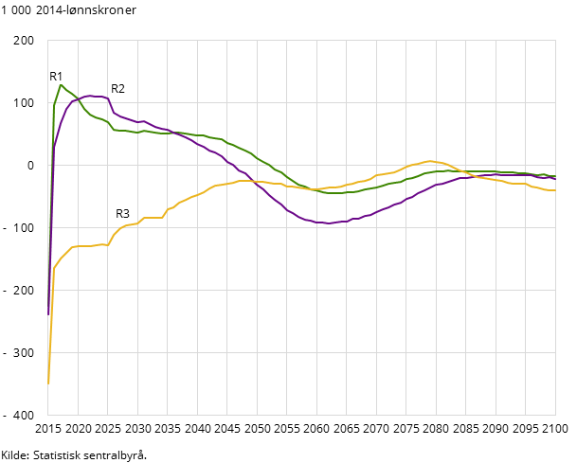 | 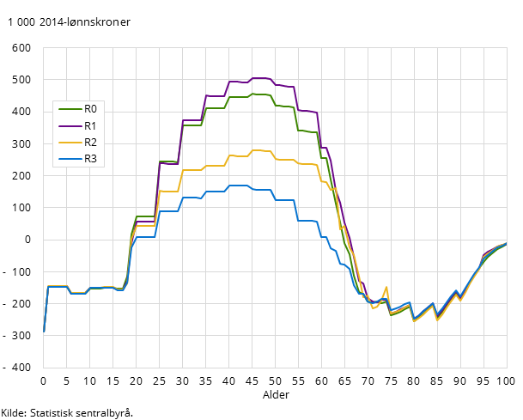

Figure 1 shows the public net income per additional immigrant of increased immigration in only 2015.
Figure 2 shows public net income of an average individual over that individual’s life cycle. The assumption is that children of immigrants (R0) have the same public net income as non-immigrants. Individuals from R3 have lower participation rate in the workforce and therefore have a lower net income. Group R0 and R1 are more likely to be higher educated and have higher income.
The debate following the 2012-publication included a lot of misinterpretations of the results, therefore the authors included a sum of public net income over the life cycle of an average individual from each group.

Figure 3 Total public net income over a lifetime in Norway for an average individual from different regions. Survival Shares of 2010. R0-individuals counted from 0 years. Individuals from R1, R2 and R3 arrives as 25 year olds. 2014 million NOK based on 4% nominal discount rate
R0 | R1 | R2 | R3
5,9 | 10,7 | 3,5 | -1,3

4.2 Employment and wellbeing of family members

Employment among immigrants in general
Immigrants had an employment rate of 60.3 per cent in the 4th quarter of 2015. In the rest of the population this rate was 67.2 per cent. There are, however, large disparities among the immigrant groups. Immigrants from the EEA countries, who include large numbers of labour immigrants, have considerably higher rates than other immigrants. The employment rates among these groups in the 4th quarter of 2015 were as follows: 73.3 per cent (the Nordic countries), 68.8 per cent (EU countries in Eastern Europe) and 67.2 per cent (Western Europe). Next, we find immigrants from North America and Oceania and Eastern Europe outside the EU, with employment rates of about 62 per cent, while the group from Latin America lay slightly above 60 per cent. Asians, meanwhile, had a lower rate, at 53 per cent. As in earlier years, the African group had the lowest rate, at 40.7 per cent (Statistics Norway, 2015). Nearly 380 000 immigrants were employed in the 4th quarter of 2015. This group constituted 14.7 percent of the total number of employed persons in Norway.
Figure 4 Employed immigrants 15-74 years, per cent of immigrants in total (Statistics Norway)
Figure 4 divides employment rate by gender. The figure shows that rate of employment is lower among women than men. The figure also shows that rate of employment is declining among immigrants in total (Statistics Norway, 2015). The decline might be ascribed to the lowering level of labour immigrants following the drop in petroleum prices and the impact this had on the Norwegian economy.

Employment by reason of immigration
There is a lower employment rate among refugees than the other categories. Labour immigrants has the highest rate of employment, at 78 percent and 80 percent for men and women respectively.
Figure 5 Employment rate among immigrants in 2015, by reason of immigration (IMDI)

Income among immigrants
The next figure shows net income level among immigrants by reason of immigration relative to the population in total. For the overall population the median income in 2014 was 348 800 NOK per year, for immigrants in total the median income in 2014 was 251 500. Immigrant have almost 100 000 NOK less income annually than the overall population. When we divide the immigrants by reason of immigration we see that Family immigrants earn a bit above the median income for immigrants in 2014 at the level of 256 800 NOK per year. The figure also show increased differences in income between immigrants and the overall population.
Figure 6 Immigrants' after-tax income, by reason for immigration and time

4.3 Impact on population structure
The main impact from immigration on population structure is the effect on population growth, net migration lead to the bulk of population growth the latest years.
Figure 7 Excess of birth, net migration and population growth (1st quarter)
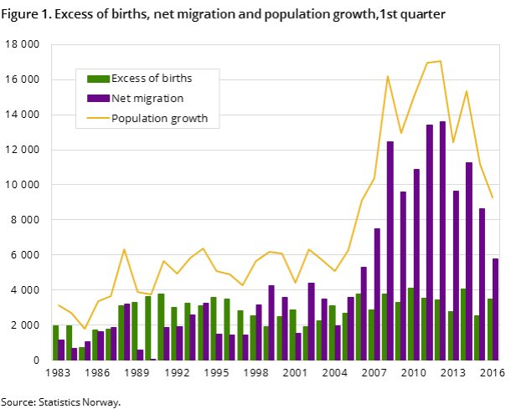

The next figure show statistics on immigration in total. The bars in the figure divide immigrants into groups based on the reason for immigration, the number of immigrants in these groups are shown in the first y-axis. The second y-axis corresponds to the line presenting total immigration.
Figure 8: Number of immigrants, and reason for immigration, source: IMDI

If we look at family immigration by the residency of the person in Norway we can see that one third of family immigration is to Norwegian or Nordic residents, the second largest group is labour immigrants, and the third is refugees.
Figure 8 Family immigration by the residency in Norway

Education
We compare the level of education for persons over 16 years old between the overall population, immigrants and Norwegian-born persons to immigrant parents. The group with immigrants has larger “tails”, both with a larger share with long tertiary education and a higher share with education below upper secondary level. There is also data on the children of immigrants. This group has a larger share with lower education than other groups. This is probably because the group is dominated by relatively young people.
When we divide the immigrants into reason for immigration the results show that those who migrate for educational purposes are more highly educated, while refugees have a larger share with no or little education.
Figure 9 Persons 16 years and older, by level of education and immigration category (2015) Source: Statistics Norway

Figure 10 Immigrants 16 years and over, by level of education and reason for immigration (2015). Source: Statistics Norway

4.4 Positive impacts on the economy (taxes, work force etc.)

Described in the 4.1.

5. Administrational impacts of family reunifications
In 2015, Bergeningsutvalget published a report on “Municipalities’ expenses concerning accommodation and integration of refugees and persons with humanitarian residency in 2014”. This report used registered data and survey results to calculate the total expenditure per person in need of different services affiliated with immigration. The target group for this report are refugees and persons with humanitarian residency, including family reunifications with those persons. Municipalities receive a grant for each immigrant accepted as a settler, the objective of this report is also to compare the level of this grant to the estimated expenses.
Altogether, the municipalities' average expenses were estimated at 770 300 NOK per refugee over a five-year period where it is also paid an integration grant. Total expenses for the target group consists of social benefits (92 600), introduction benefits (199 100), the qualification programs (7 600) and costs of integration measures and their administration (440 700) per person over five years, as well as a price-adjusted rate for health expenses (30 200).
Table 1 The posts studied and included in the “costs of integration measures and administration”, average and median NOK per year per refugee.
 | Average NOK | Median NOK
Social counselling | 22 800 | 18 700
Introduction programme | 20 400 | 18 400
Exam-oriented secondary school education | 5 700 | 7 000
Employment programme | 200 | 0
Accommodation and housing | 13 200 | 10 400
Personal contacts | 1 000 | 200
State grant to unaccompanied minors | 8 400 | 8 500
Child welfare | 18 700 | 17 100
Additional measures in primary school | 5 100 | 5 200
Cultural measures | 1 600 | 1 300
Day-care | 4 700 | 4 900
Common expenses | 3 200 | 2 800
Total per year | 88 150 | 81 900
Total over five years (adjusted) | 440 700

5.1 Administrational work and costs of public administration
Most of the services listed above are also provided to other persons (aside from immigrants) that are in need of the particular service. The results on administrative costs in regard to immigration is therefore only a part of total expense to the service. The results in the table above are estimated from accounting details reported by the municipalities, and survey results of what the municipality workers think is attributed to immigrants. Administration costs are reported as a part of each service, and not as a single post. The cost of each service in the table above also includes expenses of administration.

5.2 Accommodation costs for the public sector
Housing for those who need help from the municipality are not reported by group or reason for need. The municipalities are only accounting total housing expenses and the estimated results are therefore based on municipalities’ workers’ reports on housing for immigrants. This information is collected by survey. The average costs of housing per refugee is estimated to be 13 200 NOK, but the variation is large. Municipalities may choose whether they manage their housing programme with rented accommodation or housing owned by the municipality. Because some municipalities only use owned property, they do not always have as much direct expenses associated with housing. In the survey selection of municipalities, the range of expense is from a net income of 50 NOK to a net cost of 20 000 per person.

5.3 Educational costs (language, culture, integration)
The right and obligation to participate in an introduction programme apply to newly arrived foreign nationals between 18 and 55 years of age who need to obtain basic qualifications and who have been granted asylum (or a residence or work permit as per the Immigration Act section 8, 9 or 22 with the restrictions mentioned in the Act). Refugees receive economic support whilst participating in the introductory programme. Labour immigrants and their family can also participate in the integration programs, but need to pay a fee.

5.4 Costs for service production in public sector (day care, health, school)
See Table 1 above.

5.5 Benefits of family reunification for municipalities and other local/regional units
Population growth. In greater detail see page 26 at 4.3.

6. Other Effects

4.1 Signal effects of the new legislation
The regulations and requirements for family reunification have an important signal effect. The formal intentions with requirements are as we have discussed often a mix of the following: to reduce the numbers of asylum seekers, to increase integration (work, education and the self-independence) and to combat forced marriages. However, the policies often have important symbolic and political effects. In Norwegian politics immigration is important issue. The Progress Party has a kind of “sakseierskap”/case-ownership” when it comes to immigration. This also influence the other parties in that they have to show that they also have policies that aim to control immigration.

4.2 Security issues
“Controlled immigration” is an important issue in Norway. However, it is not unique for family reunification. The security issues have mainly been about ID, verification and economic consequences of immigration for welfare state and budget. The new laws in June 2016 give for example wider authorisation of the use of fingerprinting and facial recognition technology, and the time period biometric data can be stored for has been extended.

4.3 Other issues
N/A

Forarbeider/prepatory law: NOU 2004:20 Ny utlendingslov Ot.prp. nr. 75 (2006-2007) Om lov om utlendingers adgang til riket og deres opphold her (utlendingsloven). Ot. prp. nr. 17 (2006-2007) Om lov om endringar i utlendingsloven (DNA-testing og aldersundersøking mv.) Ot.prp. nr. 72 (2007-2008) Lov om endringer i utlendingslovgivninga (reglar for EØS- og EFTA-borgarar o.a.) Ot.prp. nr. 36 (2008-2009) Lov om endringer i utlendingsloven 1988 og utlendingsloven 2008 (gjennomføring av forordning nr 767/2008 og rådsbeslutning nr. 633/2008 vedrørende visuminformasjonssystemet Ot.prp. nr. 97 (2008-2009) Lov om endringer i utlendingsloven og i enkelte andre lover Ot.prp. 26 (2008-2009) Om lov om endringer i utlendingsloven (krav om at referansepersoner må ha fire års arbeid eller ­utdanning i Norge for at søkeren skal ha rett til ­familieetablering) Prop. 30 L (2009-2010) Endringer i utlendingsloven
https://www.regjeringen.no/no/aktuelt/oker-underholdskravet-for-familieinnvandring/id2485520/
Ot.prp. 26 (2008-2009) Om lov om endringer i utlendingsloven (krav om at referansepersoner må ha fire års arbeid eller ­utdanning i Norge for at søkeren skal ha rett til ­familieetablering)
https://www.regjeringen.no/no/dokumenter/prop.-90-l-20152016/id2481758/
https://www.regjeringen.no/en/aktuelt/nodvendige-innstramninger/id2505028/
https://www.regjeringen.no/no/dokumenter/horing---forslag-til-endringer-i-utlendi/id660324/
Section 42 Residence permit for children, Section 43 Family reunification between a child with a residence permit under sections 28 or 34 and the child’s parents and siblings. Section 44 Family reunification between a Norwegian child and the child’s mother or father. Section 45 Residence permit for a mother or a father who is to have right of access to a Norwegian child
https://www.regjeringen.no/no/aktuelt/oker-underholdskravet-for-familieinnvandring/id2485520/
Lov om introduksjonsordning og norskopplæring for nyankomne innvandrere (introduksjonsloven).
The Act on Norwegian nationality (the Norwegian Nationality Act)
Ot.prp nr. 26 (2008-2009).
NOU 2004:20
NOU 2004:20, page 404
ISF (2015): Tiltak mot tvangsekteskap i utlendingsregelverket. Institutt for samfunnsforskning. Rapport 2015:4
ISF (2015): 18
ISF (2015):18
Holmøy, E., and B. Strøm. Makroøkonomi og offentlige finanser i ulike scenarioer for innvandring. No. 15. Report, 2012.

